***covid – 19 vaccine***

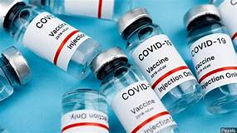

The world is in the midst of a COVID-19 pandemic. As WHO and partners work together on the response -- tracking the pandemic, advising on critical interventions, distributing vital medical supplies to those in need--- they are racing to develop and deploy safe and effective vaccines.

Vaccines save millions of lives each year. Vaccines work by training and preparing the body’s natural defences – the immune system – to recognize and fight off the viruses and bacteria they target. After vaccination, if the body is later exposed to those disease-causing germs, the body is immediately ready to destroy them, preventing illness.

As of 18 February 2021, at least seven different vaccines across three platforms have been rolled out in countries.

***INDIA’S COVID VACCINE***

1. ***COVAXIN***

Bharat Biotech, a 24-year-old vaccine maker, has a portfolio of 16 vaccines and it exports to 123 countries.

Covaxin is an inactivated vaccine which means that it is made up of killed coronaviruses, making it safe to be injected into the body. Bharat Biotech used a sample of the coronavirus, isolated by India's National Institute of Virology.

When administered, immune cells can still recognise the dead virus, prompting the immune system to make antibodies against the pandemic virus.

1. ***COVISHIELD***

The Oxford-AstraZeneca vaccine is being manufactured locally by the Serum Institute of India, the world's largest vaccine manufacturer. It says it is producing more than 50 million doses a month.

The vaccine is made from a weakened version of a common cold virus (known as an adenovirus) from chimpanzees. It has been modified to look more like coronavirus - although it can't cause illness.